DF

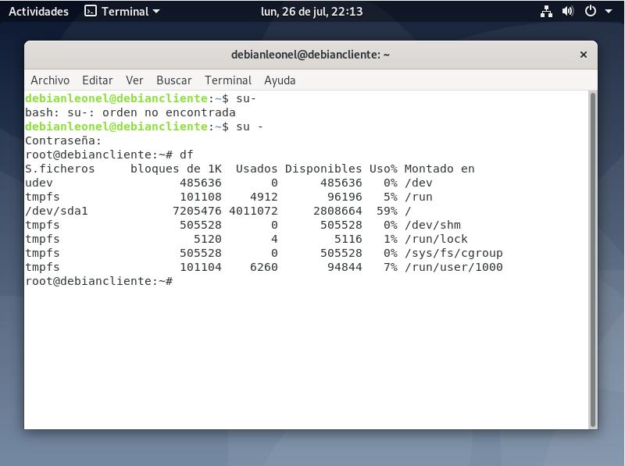

TOP

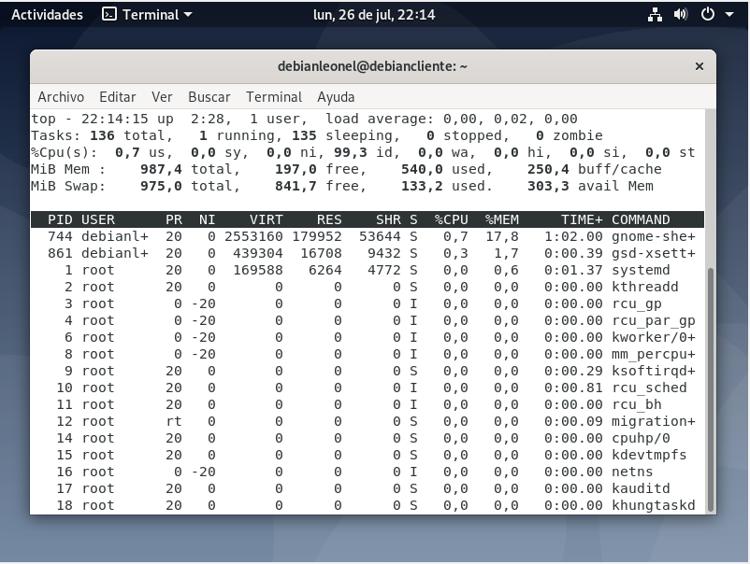

APT-GET UPTGRADE

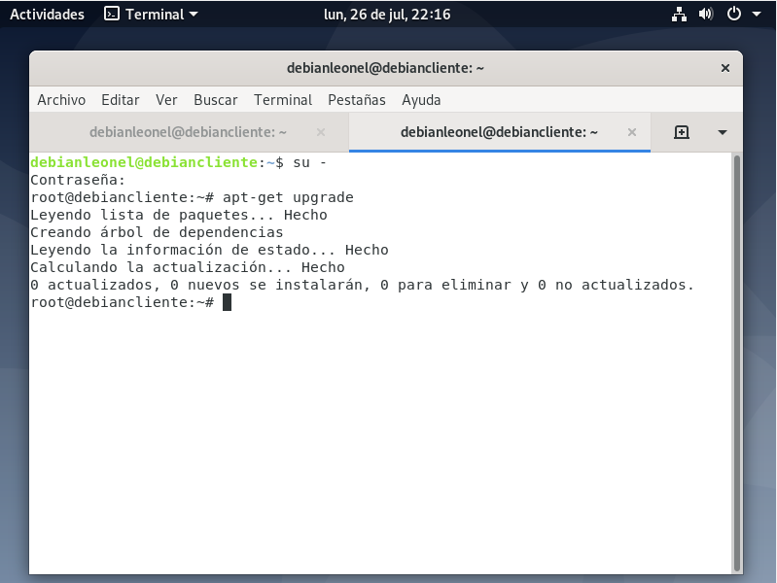

APT-GET INSTALL COWSAY

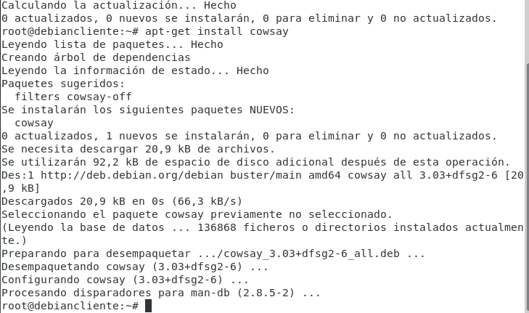

COWSAY HOLA MUNDO

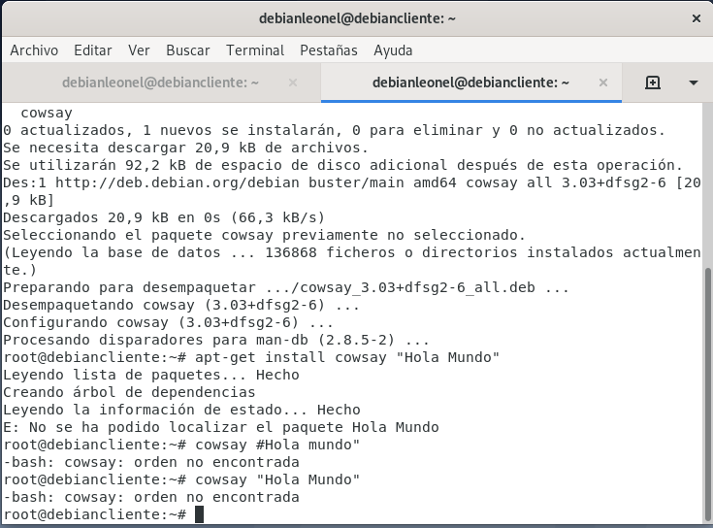

BREVE DESCRIPCION:

Apt-get upgrade

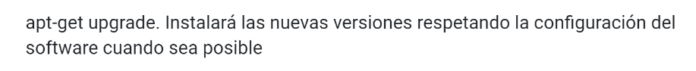

df



APT-GET INSTALL COWSAY

Instala COWSAY